Anteater Puppet
Materials:
- Construction paper (one piece per student).
- Ruler.
- Scissors.
- Tape.
- Glue.
- Pipe cleaner (one per student).
- Drawing implements (optional).
- Stapler (optional).

Instructions:
- Cut a quarter-circle wedge out of the construction paper approximately 9 inches long on each side (see diagram at right).
- Cut a much smaller quarter-circle off the wedge on the 90° angle (see diagram at right).
- Make the anteater’s head by rolling the cut paper into a cone and taping the edges together. Make sure you have a small opening at the tip of the cone. If tape isn’t very effective, a stapler may provide more stability.
- Cut out ears and eyes from the remaining construction paper and glue onto the anteater head. Students can trade extra paper to get different colors. If glue doesn’t work, try the stapler. (Optional: students can draw on and decorate their anteaters.)
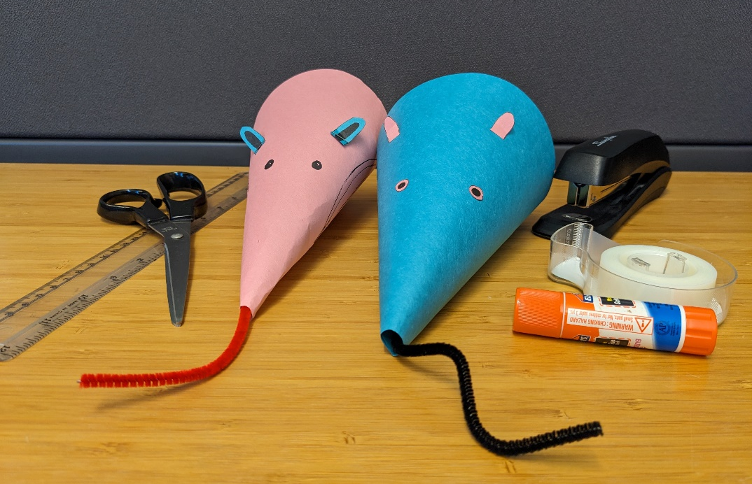
- Thread the pipe cleaner through the opening at the tip of the cone for the anteater’s tongue. This is designed to be pulled in and out of the mouth, but additional material can be used to increase the friction, or it can be taped or bent into place.

