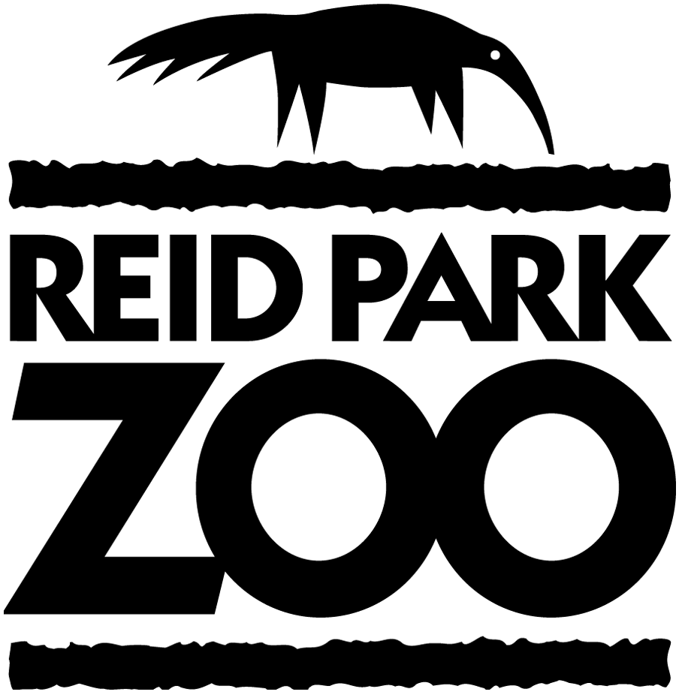

Position Description
GROUNDSKEEPER / JANITOR
Last updated May 2020

Come join us at the Reid Park Zoological Society!
Reid Park Zoological Society is seeking a Grounds Keeper/Janitor. The Society is a 501(c) (3) nonprofit organization whose mission is to support, advocate for and enhance the value of Reid Park Zoo and its mission to encourage commitment to the conservation of biological diversity and to provide educational and fun experiences for visitors of all ages. Reid Park Zoo is the largest attended cultural attraction in Southern Arizona with approximately 500,000 visitors annually. Be a part of a vibrant, growing organization as Reid Park Zoo implements an exciting master plan that will be investing over $60M in new exhibits over the next ten years. To apply, please forward a resume to hr@reidparkzoo.org No phone calls or visits please.
Overview:

The Grounds Keeper/Janitor position is responsible for assisting the Grounds Department to maintain zoo grounds and keep them clean and attractive by performing general duties. This is a hands-on position in a fast-paced environment of a growing organization. Reid Park Zoological Society is an equal opportunity employer.

GROUNDSKEEPER / JANITOR
Reports To: Grounds Supervisor

Responsibilities:

- General duties:
Safely uses and maintains hand tools & various gas powered equipment such as mowers, blowers, power-washers, trimmers, loppers, weed-eaters, rakes, shovels, and sod cutters. May be required to perform tree trimming and safely operate power equipment from ladders.

De-litters zoo grounds and around buildings. Removes trash, leaf litter and brush. Custodial work throughout the Zoo property.

Safely operates golf carts, dumping utility vehicles, riding mowers, and depending on skill level also skid steers, forklifts, tractors, and transports equipment by pulling trailers.

Conducts preventative maintenance and ensures safety.

Assists with irrigation head replacement, minor irrigation repairs and adjusts controller programs for turf conditions and over seeding.

Plants and maintains landscape with an emphasis on edible browse for the animal collection.

Cleans public restrooms according to CDC standards

Performs janitorial duties to include emptying trash receptacles, sweeping, mopping , dusting & sanitizing all areas of contact

Able to work alone or in a team environment

Must be able to mix chemicals precisely for all cleaning purposes

Help out with the setup and tear down of all zoo events

- Administrative Functions

Perform duties in accordance with RPZS policies.

Provide excellent customer service as a component of all job duties.

Follows Zoo safety protocols and procedures

- Other Duties as Assigned

Preferred Qualifications, Skills and Abilities
- 6 months grounds /custodial experience preferred.
- Ability to learn to identify plants that are suitable for animal browse??
- Pruning experience. ???
- Valid and unrestricted driver’s license.
- Excellent interpersonal and communication skills.
- Employee should be assertive, energetic, and enjoy working in a fast-paced environment.
- Ability to take direction and be quick to act or change direction as needed.
- Reliable and able to work to a schedule.
- Regular physical attendance at work.
- Employee is expected to work outside and must be comfortable working in either cold or hot weather conditions.
- Employee should be able to lift and carry heavy objects (up to 50+ lbs. on occasion)
- Comfortable walking and standing for long periods of time.
- Must be able to work flexible work schedules including evenings and weekends.

Please note that this is not an exhaustive list. It is intended to give a reasonable idea of what might be required.

Reviewed By: | Print Name | Signature | Date
Employee:
HR Director:

